**Geography Notes:**

Hierarchy: in geographic principles, generally refers to the way geographical areas are organized and structured from larger to smaller units, each with varying levels of detail and authority. This hierarchical organization helps in understanding and managing spatial relationships and data more effectively. Here are some key aspects of how hierarchy operates in geography:

1. Scale and Level of Detail: in geography, hierarchy often relates to the scale of the map or data set, where different levels of detail are shown depending on the scale. Larger areas (like continents) are depicted with less detail, while smaller areas (like cities or neighborhoods) are shown with more detailed features.
2. Administrative Divisions: geographic hierarchies are also evident in political and administrative divisions such as countries, states, provinces, districts, and municipalities. Each level down the hierarchy generally represents a smaller geographic area with its local governance.
3. Urban Planning: in urban planning and management, hierarchy is used to structure everything from road networks (major highways down to local streets) to public transport systems (main lines down to feeder routes).
4. Ecological and Physical Systems: hierarchical principles apply to natural as well as human-created systems. For example, watersheds are often structured hierarchically, with smaller tributaries feeding into larger rivers.
5. Data Management: in Geographic Information Systems (GIS), data is often structured hierarchically to allow users to drill down from more general to more specific information. This is useful for analyzing patterns and trends at different geographic levels.

Accessibility: generally, refers to the ease with which people, goods, and services can reach different places within a given area, influenced by the physical, economic, and social environments. It is a key concept in urban planning, transportation, and geography because it affects how we live, work, and interact with our surroundings. Here are the main components that define accessibility:

1. Transport Infrastructure: the availability and quality of transportation systems such as roads, railways, and public transit play a significant role in accessibility. Efficient and extensive networks can dramatically increase accessibility.
2. Distance: accessibility is often measured by the distance between points, which can be actual physical distance or time distance, considering how long it takes to travel from one location to another.
3. Economic Factors: costs associated with travel, whether in terms of money, time, or effort, also affect accessibility. For instance, if public transit is affordable, more areas become accessible to more people.
4. Social Factors: different populations may experience varying levels of accessibility based on socio-economic status, physical ability, or other demographic factors. For example, individuals with disabilities may have different accessibility needs that must be accommodated.
5. Technological Solutions: innovations such as ridesharing apps, real-time transit updates, and improved logistical systems can enhance accessibility by making it easier to find and use transportation options efficiently.
6. Policy and Planning: decisions made by urban planners and policymakers can significantly influence accessibility. Effective planning can ensure that facilities and services are distributed in a way that maximizes accessibility for the entire population.

Diffusion: refers to the process by which a phenomenon spreads over space and through time from one location to another. This concept is pivotal in understanding how various cultural, economic, technological, and environmental changes propagate through regions and populations. Here are the main types of diffusion in geography:

1. Expansion Diffusion: this occurs when a trend or phenomenon spreads outward from its origin while remaining strong in its original location. Expansion diffusion can be subdivided into three types:

* Contagious Diffusion: the phenomenon spreads adjacently, much like a virus, affecting those areas closest to the origin first. It’s typically seen in the spread of diseases, rumors, or viral social media trends.
* Hierarchical Diffusion: this form of diffusion skips over areas to spread first among the most connected or significant points, often from larger to smaller places. It is common in the spread of fashion trends or new technologies, starting in major cities and later reaching smaller towns.
* Stimulus Diffusion: a specific aspect of an idea or innovation stimulates imitative behavior in a new location, though the overall concept may not stay the same. For example, the adoption of fast-food business models in different countries might include local cuisine adaptations.

1. Relocation Diffusion: this occurs when people move from their original locations to new ones, taking their cultural practices, ideas, or innovations with them. Relocation diffusion is evident in the spread of languages, cuisine, religions, and other cultural traits as people migrate around the world.

Complementarity: refers to a relationship between two places whereby one area produces a surplus of a particular commodity or service that is demanded by another area, creating a natural flow of goods, services, or people between these locations. Complementarity is foundational for explaining trade and movement patterns within and between regions. Here’s how it operates in various contexts:

1. Economic Complementarity: this is the most common form of complementarity and involves economic interactions where one region's production meets another region’s needs. For example, a rural area might produce agricultural products needed by an urban area, while the urban area supplies manufactured goods or services not available in the rural area.
2. Resource Distribution: complementarity can also arise from the way natural resources are distributed geographically. For example, a country with abundant oil resources but lacking in technological infrastructure may complement another country that has the technology for oil refining but lacks natural oil reserves.
3. Tourism and Services: regions can be complementary in terms of tourism, where one area offers cultural attractions or natural landscapes that attract visitors from regions that do not possess these features. Similarly, specialized medical or educational services available in one region may attract users from other regions where these services are absent.
4. Labor and Skills: different regions may have surpluses of labor or specialized skills that are in demand elsewhere. This creates a complementarity based on employment opportunities and workforce needs, often seen in migration patterns.
5. Transportation and Accessibility: the effectiveness of complementarity is also influenced by the ability of goods, services, and people to move between the complementary areas. Improved transportation and fewer trade barriers enhance complementarity by making it easier and cheaper to exchange goods and services.

The Continents:

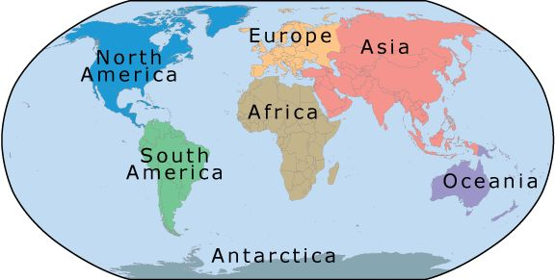

The Oceans

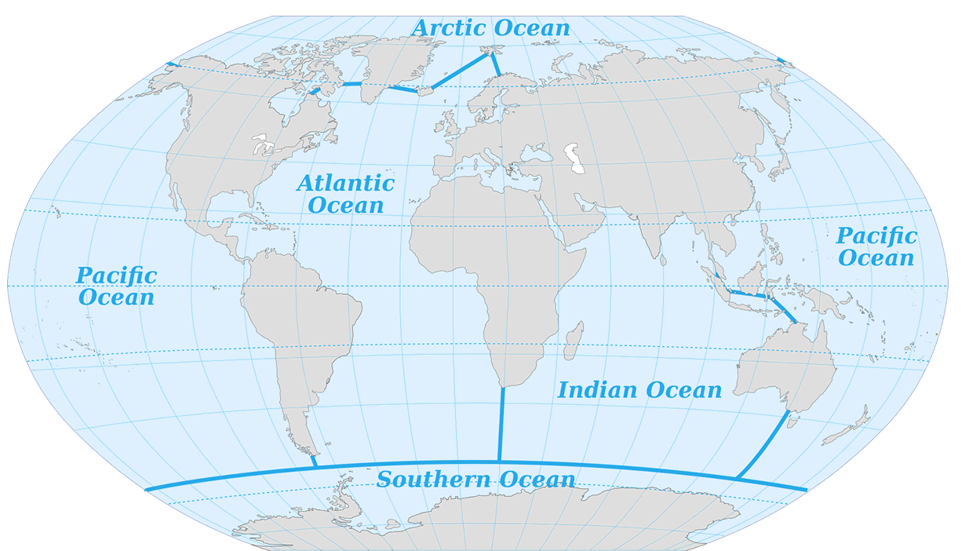

Nominal locations are the names of a place.

Direction is the location of something relative to something else.

Distance is a mathematical concept and used to determine the space between two or more features using some form of measuring unit.

Absolute location is the exact x- and y- coordinate on the Earth.

Relative location is the location of something relative to other entities.

The "four laws of geography" are often associated with the influential geographer Waldo Tobler, who is best known for formulating the "First Law of Geography." While Tobler explicitly stated only his first law, his overarching principles can be extended into broader themes that are commonly recognized in the field of geography. Here's a breakdown of Tobler's First Law and how it might be expanded into four thematic laws:

1. First Law of Geography: "Everything is related to everything else, but near things are more related than distant things."

* This law highlights the concept of spatial dependency, suggesting that the interaction between two locations decreases as the distance between them increases. It's a foundational idea in spatial analysis and geographic information systems (GIS), influencing how geographers and planners assess relationships in geographic data.

1. Second Law of Geography: Accessibility and Connectivity

* While not explicitly stated by Tobler, a logical extension of his first law emphasizes the importance of accessibility and connectivity in understanding geographic patterns. This principle pertains to how easily one can reach a location or how well-connected different locations are, affecting everything from urban planning to the spread of information and diseases.

1. Third Law of Geography: Scale and Resolution

* The impact of scale and the detail of resolution in observing and analyzing geographical phenomena is crucial. At different scales, geographic data can reveal different patterns and relationships. This law emphasizes the importance of considering the appropriate scale for studying geographic phenomena to ensure accurate analysis and decision-making.

1. Fourth Law of Geography: Human-Environment Interaction

* This principle reflects the dynamic and reciprocal relationship between human activities and the natural environment. Geographers study how human actions modify the environment and how these environmental changes impact human decisions and societal development.

In geography, "scale" is a fundamental concept that refers to the relationship between the size of features on a map and their actual size in the real world. Scale can also refer to the level at which geographic phenomena are analyzed, ranging from local to global. Understanding scale is crucial for interpreting maps correctly and for conducting geographic analysis. Here are the primary ways in which scale is used in geography:

1. Cartographic Scale: This refers to how map features relate to real-world distances. It is usually expressed in two ways:

* Ratio or Fractional Scale: represented as a ratio or fraction (e.g., 1:50,000), indicating that one unit of measurement on the map (such as an inch or centimeter) corresponds to 50,000 of the same units in the real world.
* Graphical Scale or Bar Scale: a visual line marked with distances that represent actual ground distances at the scale of the map, helping users to measure distances directly on the map.

1. Analysis Scale: in spatial analysis, scale refers to the spatial extent of an analysis and can influence the results and conclusions. Different scales can reveal different patterns and relationships:

* Global Scale: studies that consider global phenomena, like climate change or economic globalization.
* Regional Scale: focuses on specific regions, considering factors like regional climates, economies, or political systems.
* Local Scale: examines very specific locales, such as neighborhoods or small communities, often with high detail.

1. Operational Scale: this involves the scale at which processes or phenomena naturally occur or at which planning and management interventions are applied, such as the watershed scale for water management or the urban scale for city planning.
2. Perceptual or Phenomenological Scale: refers to the scale at which human activities or perceptions take place, acknowledging that individuals may perceive and interact with spaces in ways that differ significantly from cartographic or analytical scales.

Geographic Scales used in research:

* + Human Settlements- community, home, body
  + National States - subdivided into de jure (“concerning law”) regions or functional regions
  + World Regions- major clusters of humankind with broadly similar cultural attributes
  + World Economy- subdivided into core, semi-periphery, and periphery

A pattern is the arrangement of objects on Earth’s surface in relation to other objects. Pattern refers to distribution – how they are spaced:

* Linear Pattern- along straight lines – rivers, streets, railroad tracks
* Centralized Pattern – objects circle other objects – Islamic city (houses and public building may circle around mosque)
* Random Pattern- no regular distribution can be seen.
* Rectilinear or Grid Pattern- reflects a rectangular system of land – farm land or early township survey systems

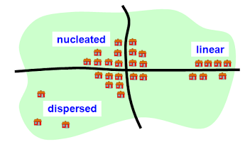

Networks- spatial interaction

* Friction of Distance - degree to which distance interferes with some interaction.  Friction of distance has been reduced in many aspects of life with improved transportation and communication infrastructures (space time compression or time-space convergence)
* Distance Decay - the interaction between two places declines as the distance between the two places increases.

Regionalization: the process of creating regions in order to better understand the world and its people.

* Region: geographers classify their information by regions, which are spatial units that share some similar characteristic. Each region links places together that share something. No two places are alike, but shared characteristics between places provide a means for geographers to group places together into more manageable unit of study. Regions are conceptual constructs used for convenience and comparison only. Regions are not only places, but also processes (ex: “American West” – changed overtime).
* Functional Region (Nodal Regions) – defined by the connections and interactions (movement) that occur between them and surrounding areas. Group of places linked together by some function’s influence on them. Often the influencing function diffused from a central node, or originating point. Interdependent parts.
* Core Area- has distinct characteristics that lessen in intensity as one travels into the periphery, or the region’s margins.
* Formal Region (Uniform Region) – have specific characteristics that are relatively uniform from one place to another within the designated region. Share a common (or uniform) cultural or physical feature.
* Vernacular Region (Perceptual Regions) – exist in the minds of people. Boundaries are determined by people’s beliefs, not a scientifically measurable process. Cultural perceptions shape the way people view their spaces.
* Sense of Place: People’s attachment to the region that they perceive as their home.

